Biotechnology Validation

Name ________________________________________________________ ____ /28

1. Bioinformatics requires a lot of information to be compared. Development in which area of technology has allowed this?

_____________________________________

(1 mark)

1. A. What are ERVs and how do they support the theory of evolution?

______________________________________________________________________________________________________________________________________________________________________________________________________________________________________________________________________________________________________________________________________________________________________________________________________________________________________________________________________________________________________________________________________________________________________________________________________________________________________________________________________________________________________________________________________________________________________________________________________________________________________________________________________________________________________________________________________________________________________________________________________

(4 marks)

B. The Study of ERVs has allowed the diagram below to be drawn.

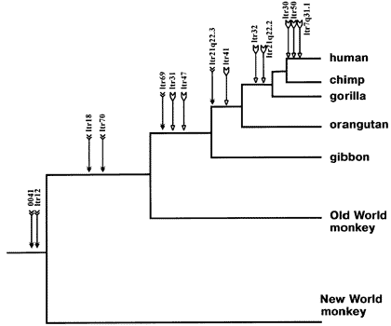

According to this diagram which group of organism would share the most ERVs with humans?

_______________________________________________

(1 mark)

1. Why are ubiquitous proteins useful when studying evolution?

______________________________________________________________________________________________________________________________________________________________________________________________________________________________________________________________________________________________________________________________________________________________________________________________________________________________

(1 mark)

1. DNA Gel Electrophoresis. In point form explain how the process of DNA Gel Electrophoresis occurs.

______________________________________________________________________________________________________________________________________________________________________________________________________________________________________________________________________________________________________________________________________________________________________________________________________________________________

______________________________________________________________________________________________________________________________________________________________________________________________________________________________________________________________________________________________________________________________________________________________________________________________________________________________

____________________________________________________________________________________________________________________________________________________________________________________________________________________________________________________________________________________________________________________________________________________________________________________________________________________________________________________________________________________________________________________________________________________________________________________________________________________________________________

(8 marks)

1. In 2008, paleoanthropologists digging in a cave in southern Siberia unearthed a 40,000-year-old adult tooth and one finger bone that had belonged to a young girl who was between five and seven years old when she died. Study of the DNA from the tooth showed that it and the finger bone belonged to a species of human called Denosivan (Homo altai).

In point form describe how such a small fragment of DNA could be amplified to allow enough DNA to study the Denosivans.

______________________________________________________________________________________________________________________________________________________________________________________________________________________________________________________________________________________________________________________________________________________________________________________________________________________________

______________________________________________________________________________________________________________________________________________________________________________________________________________________________________________________________________________________________________________________________________________________________________________________________________________________________

_________________________________________________________________________________________________________________________________________________________________________________________________________________________________________________________________________________________________________________________________________________________

(8 marks)

1. Use the diagram below to answer the question that follows.

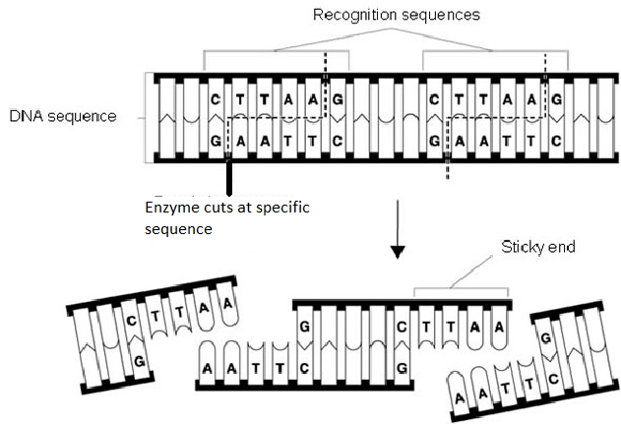

1. What type of enzyme is being used here?

______________________________________

(1 mark)

1. Although these enzymes can now be made synthetically, where were they originally sourced from?

______________________________________

(1 mark)

1. Use the diagram below to answer the questions that follow.

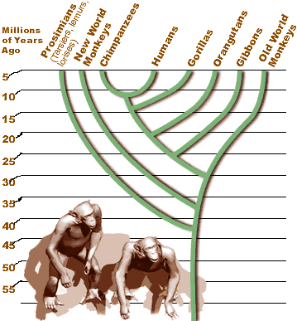

1. This diagram is an example of a what?

______________________________________

(1 mark)

1. Evolutionarily which is most closely related to Chimpanzees, gorillas or orang-utans?

____________________________________

(1 mark)

1. Approximately how long ago did Humans, Chimpanzees and Gorillas diverge from a common ancestor?

_______________________________________________________________

(1 mark)